EXPERIMENT – 1
Installation and Configuration of Kali Linux in Oracle VirtualBox

Aim
To install and configure Kali Linux as a virtual machine using Oracle VirtualBox for performing network security and ethical hacking experiments.
Software Requirements
- Host Operating System: Windows / Linux / macOS
- Virtualization Software: Oracle VirtualBox
- Guest Operating System: Kali Linux
- System Requirements:
  - RAM: Minimum 4 GB (8 GB recommended)
  - Disk Space: Minimum 30 GB
  - Processor: Intel/AMD with Virtualization support
Introduction:
Kali Linux is a Debian-based Linux distribution developed for penetration testing, digital forensics, and cybersecurity analysis.
Installing Kali Linux inside Oracle VirtualBox provides a safe and isolated environment to practice security experiments without affecting the host system.
VirtualBox is an open-source virtualization tool that allows running multiple operating systems simultaneously on a single physical machine.

Procedure:
Step 1: Enable Virtualization
- Restart the system and enter BIOS/UEFI settings.
- Enable Intel VT-x / AMD-V.
- Save changes and reboot the system.

Step 2: Install Oracle VirtualBox
- Download Oracle VirtualBox from the official website.
- Run the installer and follow default installation steps.
- Complete the installation and restart the system if required.

Step 3: Download Kali Linux
- Visit the official Kali Linux website.
- Download the Kali Linux Installer ISO (64-bit).

Step 4: Create a New Virtual Machine
- Open Oracle VirtualBox.
- Click New.
- Enter:
  - Name: Kali Linux
  - Type: Linux
  - Version: Debian (64-bit)
- Click Next.

Step 5: Allocate Memory and CPU
- Memory Size: 2048 MB or higher
- Processor: 2 CPUs
- Click Next.

Step 6: Create Virtual Hard Disk
- Select Create a virtual hard disk now.
- Choose VDI (VirtualBox Disk Image).
- Select Dynamically allocated.
- Set disk size to 30 GB.
- Click Create.

Step 7: Attach Kali Linux ISO
- Select the created VM → Settings.
- Go to Storage.
- Under Controller IDE, select Empty.
- Click Choose a disk file and select Kali Linux ISO.
- Click OK.

Step 8: Install Kali Linux
- Start the virtual machine.
- Select Graphical Install.
- Choose:
  - Language
  - Location
  - Keyboard layout
- Configure network automatically.
- Set:
  - Username
  - Password
- Choose:
  - Guided – Use entire disk
  - All files in one partition
- Confirm disk changes and continue installation.
- After completion, reboot the system.

Output:

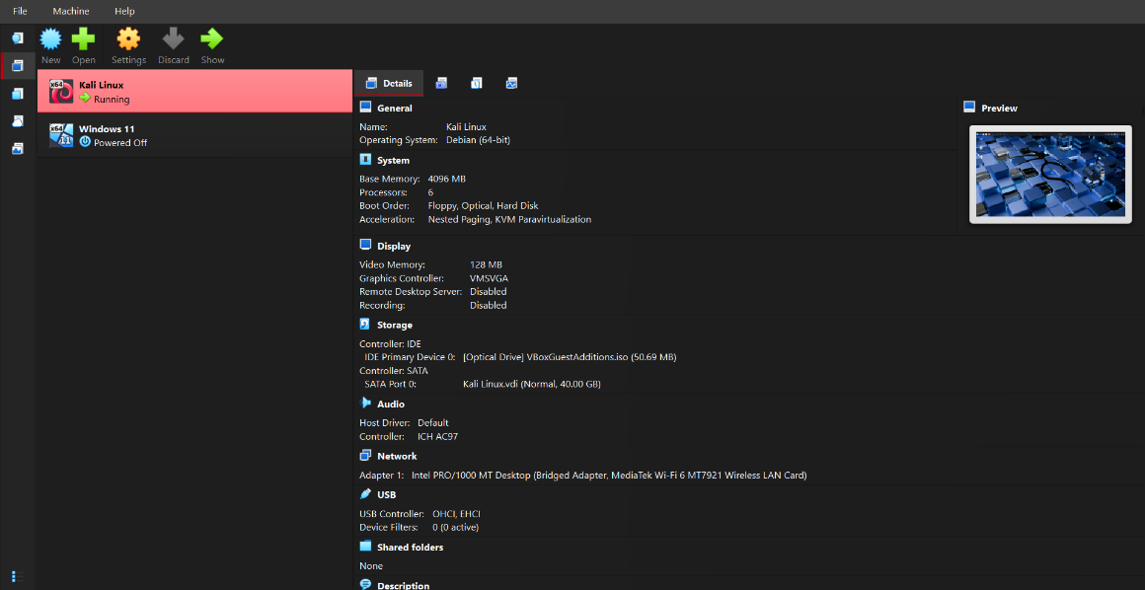

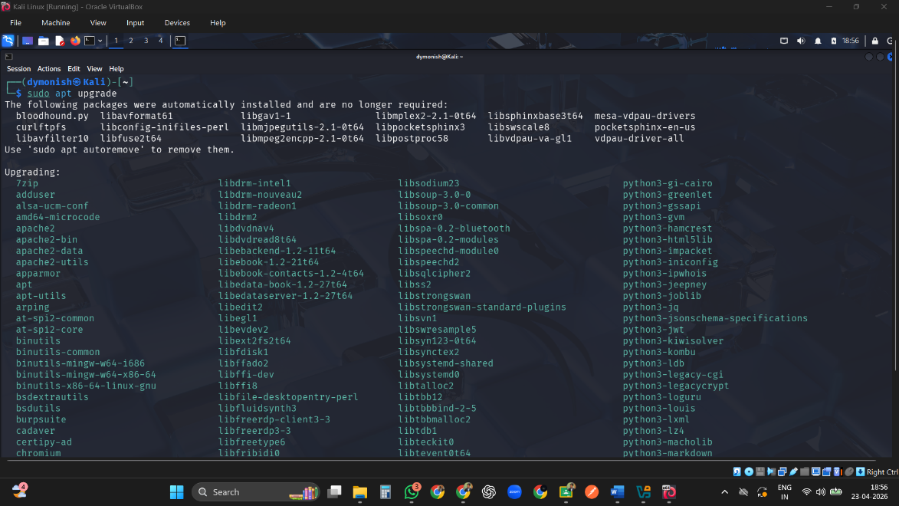

Result
Kali Linux was successfully installed and configured in Oracle VirtualBox.
The virtual machine is ready for performing network security and ethical hacking experiments.

